**Experiment-2**

Rate Study in a

Continuous Stirred Tank Reactor

*18CH10071, Anshuman Agrawal*

**Objectives**

1. To determine the order of the reaction between sodium hydroxide and ethyl acetate using a CSTR.
2. To find the rate constant at a particular temperature.

**Theory**

Stoichiometric equation:

NaOH + CH3COOC2H5 → CH3COONa + C2H5OH

1. (B) (C) (D)

Mole Balance: $\frac{V_{R}}{F_{A_{0}}}= \frac{X_{A}}{{-r}_{A}}$

Rate Equation: ${-r}_{A}=k_{2}C_{A_{o}}^{2}(1-X_{A})(M-X_{A})$

Assuming 2nd order reaction.

Where $M= \frac{C_{B_{0}}}{C_{A_{0}}}$, XA = conversion of A, k2 = rate constant

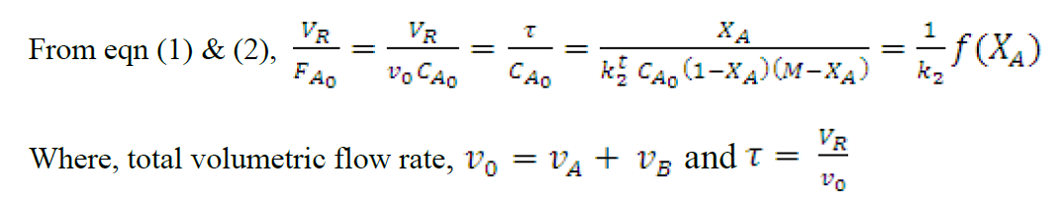

**Schematic**

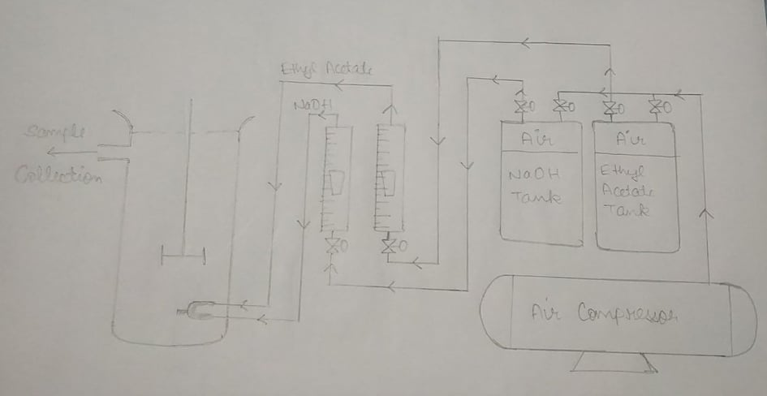

**Observations**

Strength of Succinic Acid = N/50 = 0.02 N = 0.01 M (dibasic acid)

CA0 (before mixing) = 0.05 mol/ L

CA0 (after mixing) = 0.025 mol/ L

CB0 (before mixing) = 0.1 mol/ L

CB0 (after mixing) = 0.05 mol/ L

Volume of reactor = 2.815 L

M = 2

|  |  |  |  |  |  |  |
| --- | --- | --- | --- | --- | --- | --- |
| **Flow Rate* (LPH)** | **τ (sec)** | **CA0**  **(mol/ L)** | **Titre Volume (ml)** | **XA** | **Average XA** | **f (XA)** |
| 5.2 | 974.42 | 0.025 | 1.7 | 0.728 | 0.73 | 3406.2 |
| 1.65 | 0.736 |
| 1.72 | 0.725 |
| 9 | 563 | 2.1 | 0.664 | 0.664 | 2366.7 |
| 2.2 | 0.648 |
| 2.0 | 0.68 |
| 13.5 | 375.34 | 2.6 | 0.584 | 0.6 | 1714.3 |
| 2.5 | 0.6 |
| 2.4 | 0.616 |

*\*Flow rates have been adjusted based on the calibration curve of the Rotameter*

**Sample Calculations**

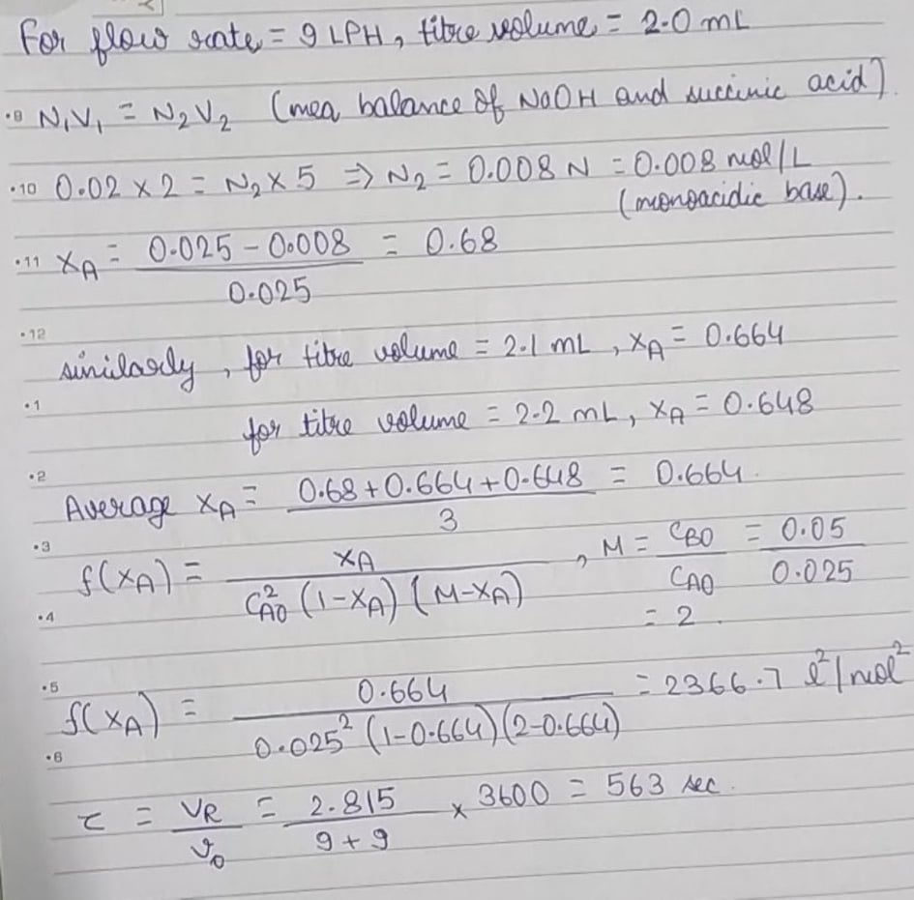

**Plot**

**Results**

Slope of above plot = 2.7755 l2 mol-2 s-1

Rate constant = slope × CA0 = 2.7755 × 0.025 = 0.069 l mol-1 s-1

Therefore, the rate constant of the given reaction under existing temperature conditions comes out to be **0.069 l mol-1 s-1**.

**Discussion**

* The rate constant value is drastically different from the one calculated using a PFR (more than 100% difference). This could be due to several underlying experimental sources of error.
* The water bath used in the experiment cannot exactly maintain a constant temperature because it also loses heat to the surrounding and is at non steady state thus, the reaction kinetics can be affected while the experiment is going on.
* Rotameters are usual sources of error because the markers inside are not in complete equilibrium thus, an approximate value is considered however, the calibration curve helps in attaining a bit of accuracy.
* Phenolphthalein must not be added in excess to the solution to be titrated.
* The colour change must be carefully noted during titration with the last drop to correctly identify the titre volume and a slight delay could result in faulty readings.
* Care must be taken that no drop of succinic acid is wasted while titrating as that can lead to error in the titre volume.
* The meniscus should be carefully observed in the titration to avoid any error in noting the titre volume due to parallax.
* The stirring rate in the CSTR must be maintained at a reasonable rate to facilitate proper mixing. In the calculations, the exit flow rate from the CSTR is not known therefore, the space time is calculated by assuming that the entry and exit flow is the same.

**Conclusion**

Therefore, through the obtained values of rate constant it can’t be concluded which reactor is better for the rate study. Both methods carry their own pros and cons and the most one can do is to eliminate as many cons as possible.